CE213 Class Problem Sheet 7 (Week 9)

(Q1) An example question of Progress Test 2:
A system is monitored by two sensors, and the two sensor readings S1and S2 are used as the inputs of the following MP neuron.
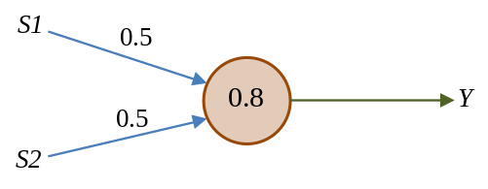
If the neuron's output Y=1, then the system is faulty. Which of the following situations indicates that the system is faulty?
[A] S1=1.8, S2=0.0
[B] S1=0.0, S2=2.1
[C] S1=1.0, S2=1.0
[D] All of the above

(Q2) Calculate the output Y of the following McCulloch-Pitts neural network of 3 MP neurons when its inputs are S1=1 and S2=1.
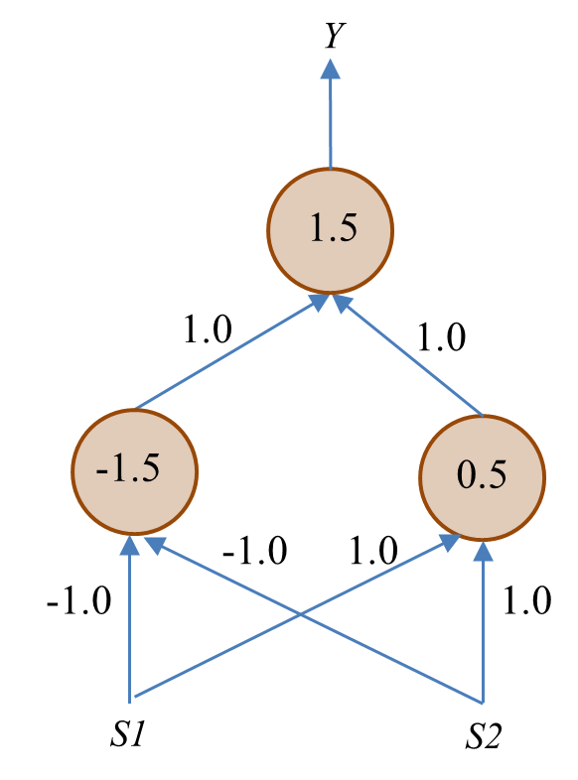

(Q3) The following table lists several attributes of five animals:
 | Dangerous? | Zoo Animal? | Stripes? | Four Legs? | Aquatic?
Bear | Yes | Yes | No | Yes | No
Tiger | Yes | Yes | Yes | Yes | No
Dog | No | No | No | Yes | No
Giant Squid | Yes | No | No | No | Yes
Cat | No | No | No | Yes | No
The similarity of two animals is defined as the number of attribute values they have in common. The similarity of two groups of animals is defined as the similarity of the most similar pair of animals where each member of the pair is from a different group. Draw the dendrogram that would be produced using the agglomerative hierarchical clustering technique.
(Hint: You will probably find it helpful to begin by drawing up a table showing the similarities between each pair of animals).

(Q4) (This is an optional question, which may be difficult to most students.)
A neural network consists of 1 output neuron, 2 hidden neurons, and 3 inputs. The neuron’s activation function is a logistic function, i.e., 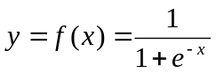 and 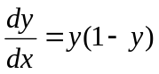. Derive the rule/equation for updating the weight between the 1st hidden neuron and the 1st input according to the generalised delta learning rule.

More questions (could be for homework):
1. What is the difference between a machine learning model and a machine learning algorithm?
2. What is structural learning? Give an example of structural learning.
3. Describe the knowledge representation methods you have learnt so far.

Topics: Neural networks and clustering

Answers or hints:

Q1: D
Q2:
When S1=1, S2=1: the input to the neuron with a threshold of -1.5 is -1x1-1x1=-2<-1.5, and thus the output of this neuron is 0; the input to the neuron with a threshold of 0.5 is 1x1+1x1=2>0.5, and thus the output of this neuron is 1; the input to the output neuron is 1x0+1x1=1<1.5, and thus the output of the output neuron is 0.

Q3:
Animal pairs Similarities
Bear & Tiger 4
Bear & Dog 3
Bear & Giant Squid 2
Bear & Cat 3
Tiger & Dog 2
Tiger & Giant Squid 1
Tiger & Cat 2
Dog & Giant Squid 2
Dog & Cat 5
Giant Squid & Cat 2

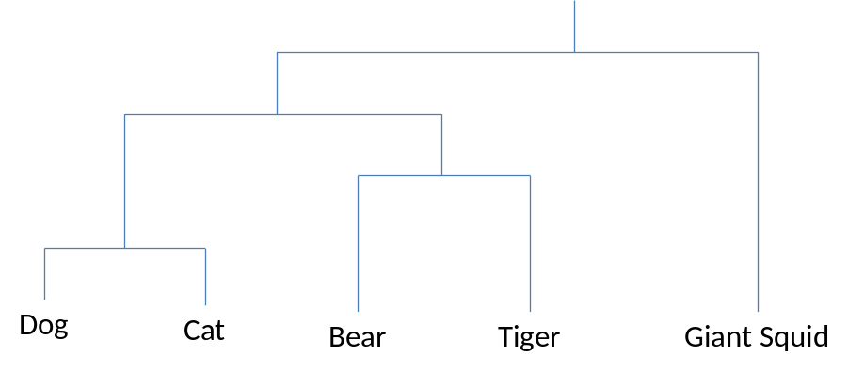
(Is this dendrogram sensible to you?)
Q4:
Let the neural network’s input-output relationship be
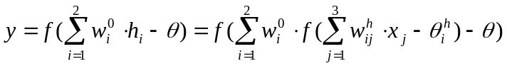
According to the generalised delta rule we have
(You may also derive this using the equations on slide 12 for lecture 15. Set y_{k} to y as there is one output neuron only.)

More questions:
1. A machine learning model is a problem solver such as a decision tree or neural network. A machine learning algorithm is for optimising models for solving problems.
2. Structuring learning is a type of machine learning that optimises/determines the structure of a model for problem solving. Decision tree induction is an example of structural learning.
3. In expert systems, knowledge is represented as IF-THEN rules. Decision tree itself represents knowledge discovered by machine learning from data. In neural networks, knowledge is represented in connections weights and neuronal biases in a distributed manner.

